- After an early-summer lull, UK GDP returned to growth in August. Though the pace of growth has clearly cooled from the well above-trend rates seen in H1 2024, the economy continues to enjoy decent momentum. We're unlikely to change our forecast that GDP will grow by 1% this year and 1.5% in 2025.
- We don't agree with the argument that a widening spread between UK gilt and German bund yields is evidence that markets are nervous about the prospect of looser fiscal policy – the rise in UK bond yields has mirrored that of US Treasuries. Even so, we expect the Chancellor to retain greater headroom to try to mitigate any concerns about changing the rules to invest more.
After a strong start to 2024, GDP had flatlined in early summer. We thought this would likely prove a blip in what can be a volatile series. And this week's data for August suggested that our optimism was well-founded. Output rose by 0.2% month-on-month in August, with all the main sectors making small positive contributions to growth (Chart 1).
Digging into the sectoral detail, most of the sectors that had seen big falls in output in July – including manufacturing, professional services, and to a lesser extent construction – rebounded in August. We had expected distribution output to recover given the strength of August's increase in retail sales. However, big monthly falls in the wholesaling and motor vehicles sub-sectors more than offset the retail pickup.
Earlier this week, we published our first forecast that incorporated the large national accounts revisions released at the end of September. Those revisions had led us to cut our forecasts for GDP growth by 0.1ppt to 1% for 2024 and by 0.2ppts to 1.5% for 2025. The former reflected growth in Q2 being revised lower, while we expect growth to be softer in 2025 because large downward revisions to the household saving ratio over the past couple of years suggest much less scope for dis-saving to boost consumer spending. August's outturn was in line with expectations, so we're unlikely to change these forecasts.
Chart 1: The economy returned to growth in August, after a softer couple of months
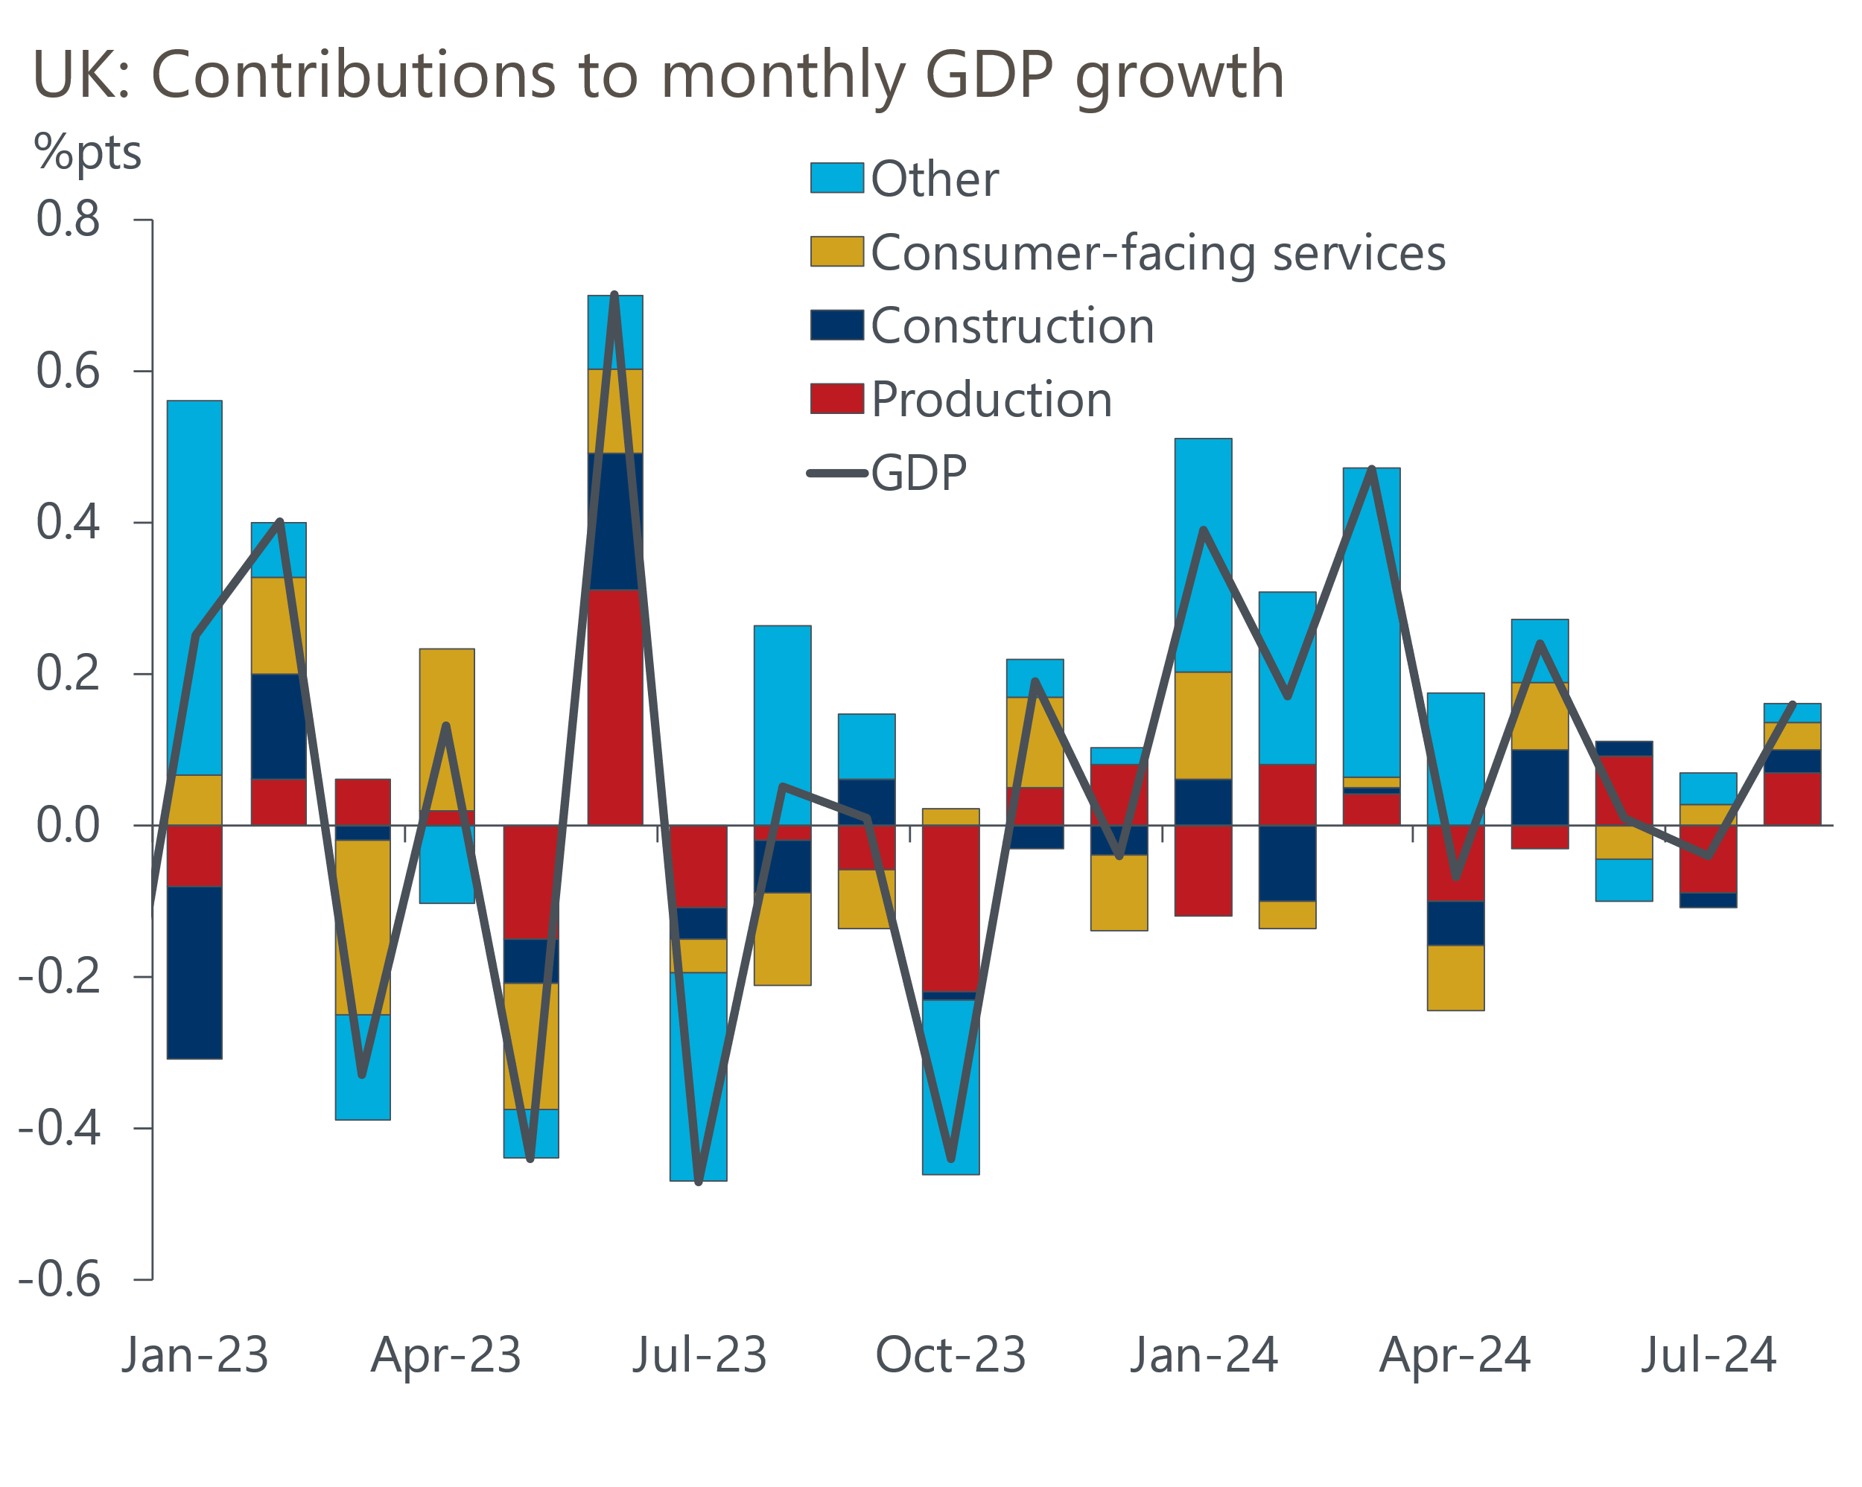
Source: Haver Analytics

UK government bond yields have climbed in recent weeks, with the 10-year yield reaching 4.22% on Thursday, the highest rate since July 2 (Chart 2). Some commentators have suggested that the fact the spread over German bunds has widened is a sign that markets are nervous about the prospect of the Chancellor loosening fiscal policy in the Budget on October 30. But we don't think the data backs this argument.
Chart 2: Rising UK gilt yields reflect US influences rather than concerns about government borrowing
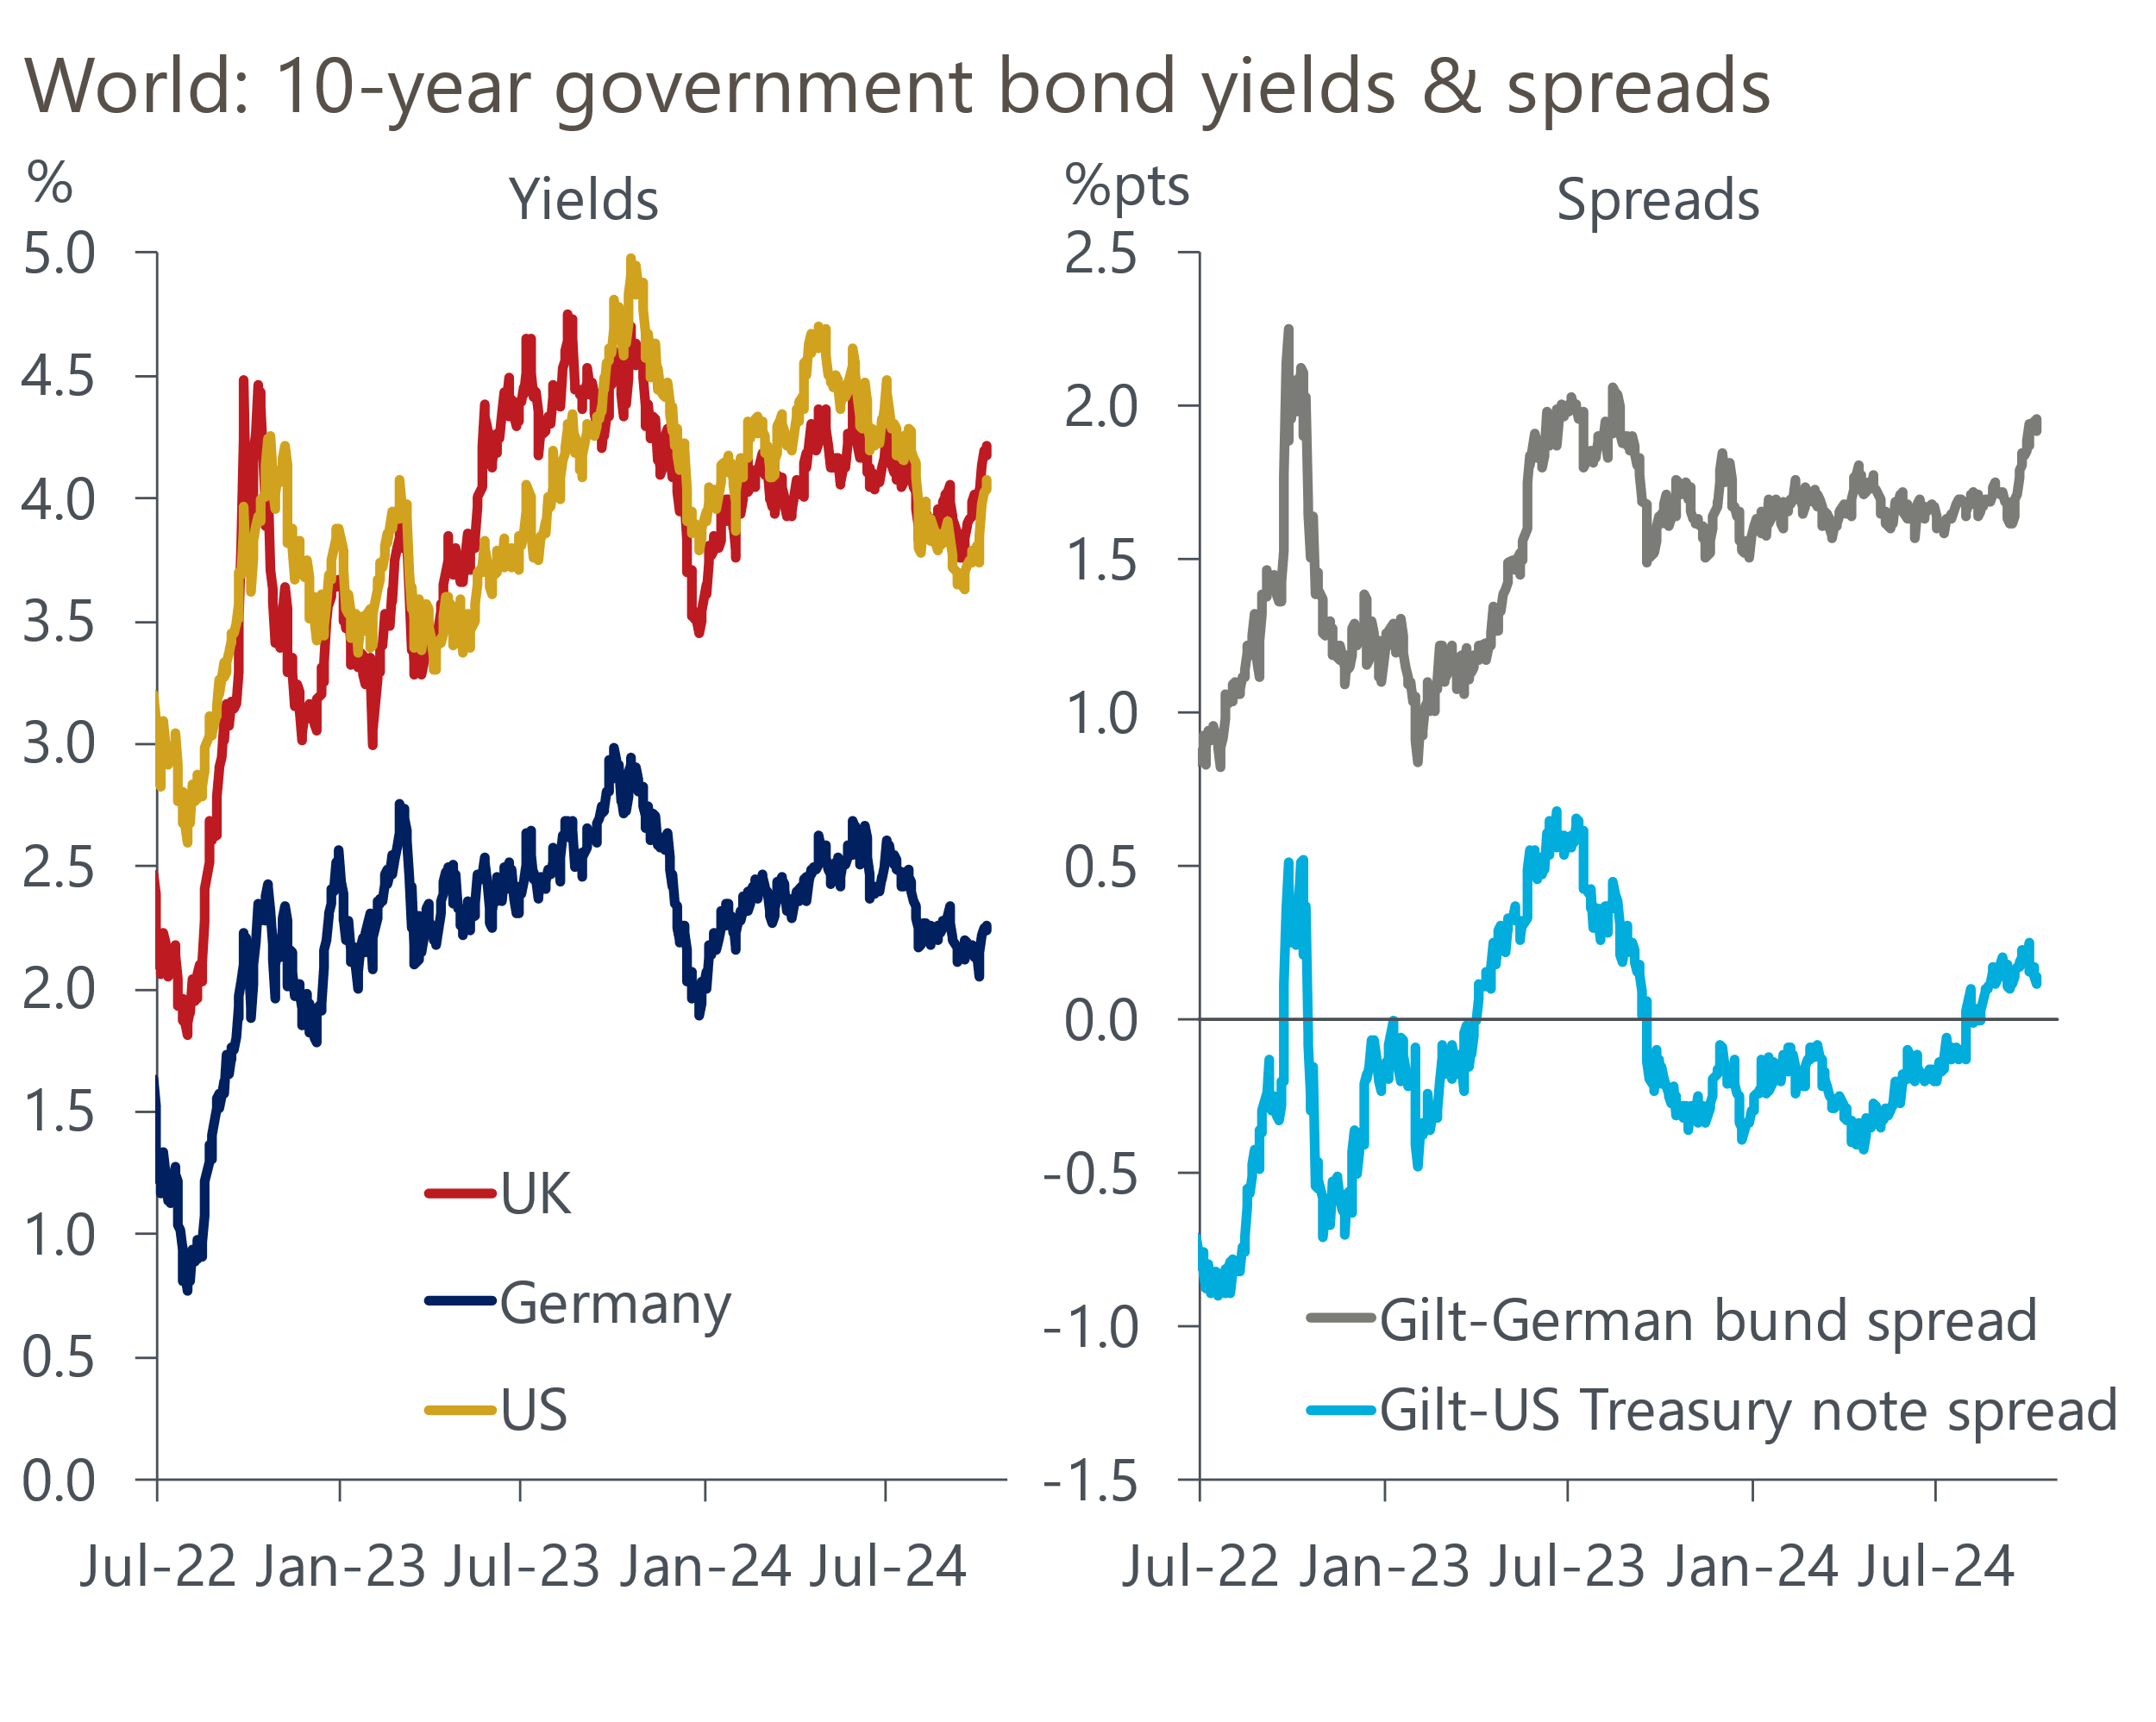
Source: Haver Analytics
Though the spread of UK gilts over German bunds has widened by more than 30bps over the past month, the spread over US Treasuries has remained stable over this period. Rather than markets being concerned about UK government borrowing, the rise in UK yields appears to be linked to markets reappraising the likely path of US monetary policy with – as often happens – UK asset prices being dragged along for the ride. By contrast, markets have become markedly more dovish about the Eurozone outlook, explaining why German yields have decoupled.
The recent rises in gilt yields and market expectations for Bank Rate won't have any impact on the Office for Budget Responsibility's fiscal forecasts – based on the timings used in March, the financial market assumptions are likely to be based on market pricing from mid-September. This should leave the OBR's forecasts for debt servicing costs little changed. But with both inflation and average earnings growth tracking above its forecasts over the past six months, and likely to continue to do so in the short-term, there's a good chance that we see a mini version of the November 2023 experience. Then, the OBR revised up its forecasts for the levels of prices and wages throughout the forecast horizon, leading to a stronger projection for tax revenues. For a Chancellor wanting to increase the size of the current spending envelope and limit the extent of tax rises, such a forecast revision would be a very welcome development.
In a recent interview with the Financial Times, Rachel Reeves vowed that "invest, invest, invest" would be the theme of the Budget, and speculation about changes to the fiscal rules has continued to build. Our analysis suggests that changing the fiscal rules could generate headroom for a substantial increase in capital spending. We've long advocated tweaking the headline debt measure to exclude losses on gilt sales from the Bank of England's Asset Purchase Facility. But an alternative option – targeting a reduction in the ratio of public sector net financial liabilities to GDP – appears to be gaining in popularity.
PSNFL counts all public sector debts and nets off liquid financial assets, illiquid financial assets (e.g. student loans to be repaid), and some other financial liabilities (e.g. funded public sector pension liabilities). If Reeves opts to switch to targeting PSNFL then assuming that any extra current spending is offset by tax rises, we calculate she could increase the level of public investment to 3% of GDP by 2028-2029 (from the 1.7% of GDP currently planned) while retaining much greater headroom against the fiscal rules and shortening the timeframe to achieve a falling debt ratio. These latter changes would surely help to mitigate any market concerns about higher borrowing.

The week ahead
The pay data cooled further in July, reflecting both strong base effects and fading momentum. With base effects now starting to fade, we expect the fall in headline (three-month average of the annual rate) pay growth to be smaller in August, with the total pay measure expected to come in at 3.8% and regular pay at 4.9%.
Labour Force Survey data remains beset by volatility, with the Office for National Statistics still to implement planned methodological improvements. With June's rogue single month reading still part of the three-month average, we expect the unemployment rate to stay at 4.1% in the three months to August. But it's then likely to rebound in next month's release when that exceptionally low June figure drops out of the calculation.
We estimate that CPI inflation temporarily dipped to 1.7% in September, which would be the lowest reading since April 2021. Two factors are likely to have weighed on inflation last month. First, there was an unusually strong reading for core inflation last September, which will create a large negative base effect for the year-on-year rate in September 2024. Second, weekly data from the Department of Energy & Climate Change reports that fuel prices fell by 4% between August and September, having increased by nearly 4% between those months last year.
Retail sales surged by 1% month-on-month in August, but we think this will prove to be noise and that most of the strength will have been reversed in September. In particular, sales in both food and non-food stores rose well above the levels seen for most of this year and these sectors look ripe for payback in September. We think sales fell by 0.8% m/m in September.
Table 1: Week ahead calendar
Date | Events | Period | Measure | Unit | Previous | Forecast
Oct 15 | LFS unemployment | Jun-Aug | Rate | % | 4.1 | 4.1
Oct 15 | Average earnings (total pay) | Aug | 3m, y/y | % | 4.0 | 3.8
Oct 15 | Average earnings (regular pay) | Aug | 3m, y/y | % | 5.1 | 4.9
Oct 16 | CPI inflation | Sep | m/m | % | 0.3 | 0.0
Oct 16 | CPI inflation | Sep | y/y | % | 2.2 | 1.7
Oct 16 | RPI inflation | Sep | m/m | % | 0.6 | 0.2
Oct 16 | RPI inflation | Sep | y/y | % | 3.5 | 3.2
Oct 16 | Producer input prices | Sep | m/m | % | -0.5 | -1.0
Oct 16 | Producer input prices | Sep | y/y | % | -1.2 | -2.6
Oct 16 | Producer output prices | Sep | m/m | % | -0.3 | -0.7
Oct 16 | Producer output prices | Sep | y/y | % | 0.2 | -1.0
Oct 16 | Land Registry house prices | Aug | y/y | % | 2.2 | 1.9
Oct 18 | Retail sales inc fuel | Sep | m/m | % | 1.0 | -0.8
Oct 18 | Retail sales inc fuel | Sep | y/y | % | 2.5 | 2.7
Source: Oxford Economics

Key forecasts
Table 2: UK forecast overview
(Annual percentage changes unless specified)
 | 2022 | 2023 | 2024 | 2025 | 2026 | 2027
GDP | 4.8 | 0.3 | 1.0 | 1.5 | 1.6 | 1.7
Private consumption | 7.3 | 0.5 | 0.8 | 1.9 | 1.8 | 1.6
Fixed investment | 5.1 | -0.1 | 0.6 | 1.3 | 2.5 | 2.1
Government consumption | 0.6 | 0.6 | 2.3 | 1.9 | 1.5 | 1.5
Exports of goods and services | 12.6 | -2.2 | -2.0 | 1.8 | 2.0 | 1.7
Imports of goods and services | 13.0 | -3.4 | 1.7 | 1.9 | 2.5 | 1.7
Industrial Production | -6.4 | -1.2 | -1.0 | 0.6 | 1.2 | 0.9
Consumer prices | 9.1 | 7.3 | 2.5 | 2.4 | 2.3 | 2.1
Unemployment rate (%) | 3.9 | 4.0 | 4.3 | 4.3 | 4.1 | 3.9
Current a/c balance (% of GDP) | -2.2 | -2.0 | -3.0 | -2.9 | -3.0 | -2.9
Government balance (% of GDP) | 4.1 | 4.9 | 3.7 | 2.8 | 2.1 | 1.4
Cen. bank policy rate (%, EOP) | 3.50 | 5.25 | 4.75 | 3.75 | 2.75 | 2.00
10yr govt. bond yield (%, EOP) | 3.67 | 3.54 | 3.92 | 3.70 | 3.26 | 2.85
Exchange rate (US$ per £, EOP) | 1.20 | 1.27 | 1.32 | 1.32 | 1.32 | 1.33
Exchange rate (euro per £, EOP) | 1.13 | 1.15 | 1.19 | 1.18 | 1.18 | 1.17
Source: Oxford Economics
Table 3: Quarterly forecasts for the UK
 | 2024 |  |  |  | 2025
 | Q1 | Q2 | Q3 | Q4 | Q1 | Q2 | Q3 | Q4
GDP (% year) | 0.3 | 0.7 | 1.1 | 1.9 | 1.6 | 1.5 | 1.5 | 1.5
CPI inflation (% year) | 3.5 | 2.1 | 2.1 | 2.3 | 2.3 | 2.2 | 2.6 | 2.5
Bank Rate (%, EOP) | 5.25 | 5.25 | 5.00 | 4.75 | 4.50 | 4.25 | 4.00 | 3.75
10yr gilt yield (%, EOP) | 3.95 | 4.17 | 4.00 | 3.92 | 3.88 | 3.82 | 3.76 | 3.70
US$ per £ (EOP) | 1.26 | 1.26 | 1.34 | 1.32 | 1.32 | 1.32 | 1.32 | 1.32
Euro per £ (EOP) | 1.17 | 1.18 | 1.20 | 1.19 | 1.19 | 1.19 | 1.19 | 1.18
Source: Oxford Economics

Latest Country Economic Forecast:
September 13, 2024

Recent publications

Data Insights
The economy returned to growth in August
Services PMI points to healthy, albeit slower, GDP growth in Q3
Manufacturing PMI ended Q3 on a softer note
Lower mortgage rates supported a jump in approvals in August
GDP revisions consolidate recovery

Research Briefings
How changing the debt rule could shape the Budget
MPC takes a breath, but cuts likely to resume in November
MPC preview – Pace of gilts sell-off is the key decision
MPC easing - how far and how fast?
Growth may slow, but the consensus looks too weak

Contacts

Oxford Economics' UK team
- Andrew Goodwin - Chief UK Economist - agoodwin@oxfordeconomics.com
- Edward Allenby - UK Economist - eallenby@oxfordeconomics.com

